**Boxy Box**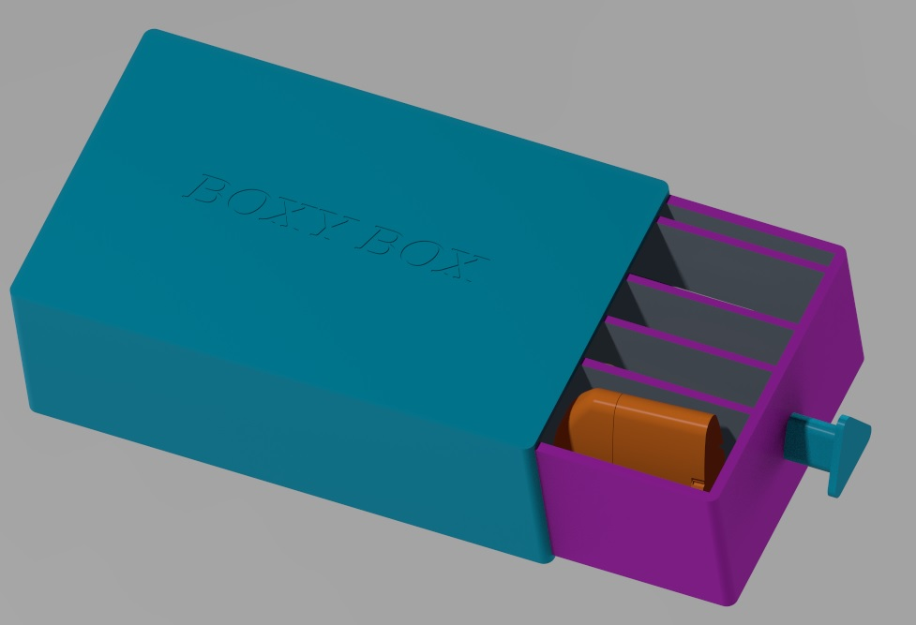

A Manual for Using YOUR Boxy Box

**Boxy Box**

# Table of Contents

Setup and Assembly..……………………………………………………………………………………2

Usage Guide…………………………………………………………………………………….……………...3

Maintenance Guide………………………………………………………………………..…………..…4

Warranty…………………………………………………………………………………………………………..5

Servicing Information ………………………………………………………….………………………6

# Setup

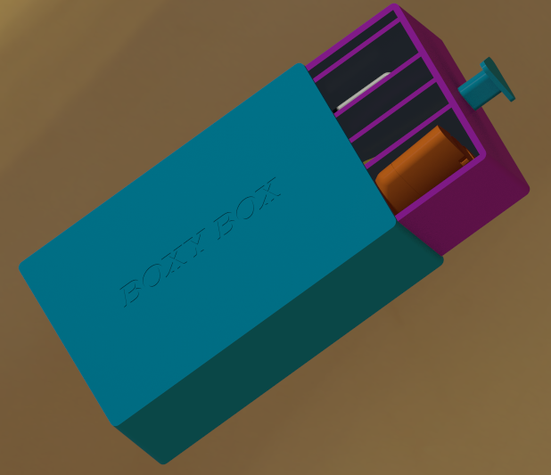

To open the Boxy Box, ensure that the white part is on the bottom of the surface to ensure none of the toiletries fall out of your Boxy Box. The top part of the Boxy Box will have “Boxy Box” engraved on it to help you differentiate between the top and the bottom of the case. Then, slide the inner box out by pulling on the Trippy Triangle - make sure to hold onto the outer shell to ensure that the box doesn’t slide.

To close your Boxy Box, slide the cover over the body as illustrated here. Remember to keep the body on a flat, stable surface and to press until the lid and the body click together for optimal security.

# Product Details

# Please ensure that the Boxy Box does not get carried by the Trippy Triangle. The Trippy Triangle is placed to make your opening of the Boxy Box more convenient for you. Additionally, do not put more than 3 pounds into the Boxy Box to ensure the product’s longevity.

# The compartment dimensions are as follows, alongside their recommended usages:

1x 9.59 by .3 slot, optimally for a comb.

1x 9.59 by 1.2 opening, optimally for a toothbrush

1x .70 by 1.82 opening, optimally for floss

1x .8 by 1.82 opening, optimally for toothpaste

1x .83 by 7.8 opening, optimally for a razor

1x .84 by 3.2 opening, optimally for larger floss containers

1x .84 by 4.5 opening, optimally for a smaller toothbrush

1x 2 by 4.5 opening, optimally for a deodorant stick

# 1x 2 by 4.94 opening, optimally for a canister of shaving cream

# Usage Guidelines

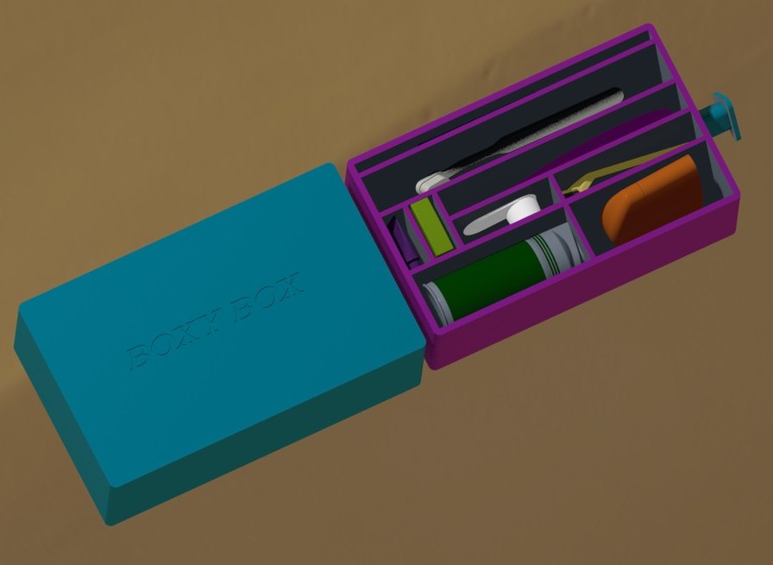

To use your Boxy Box, insert up to six toiletry items of your choice into the six compartments inside of the device.

In order to get the most traveling security out of your Boxy Box, carry it in a handbag, purse, or other small carrying bag as opposed to a larger suitcase or a clothing pocket.

For greater distance from the surface of the countertop, sink, et cetera, place the drawer, opening up, on top of the shell..

# Maintenance

In order to maintain your Boxy Box, ensure a tight seal is always maintained to prevent spillage. Do not subject your Boxy Box to drastic changes in temperature, caustic materials, or any chemicals not found in body washes, toothpaste, and other skin-approved applications. Do not attempt to subject your Boxy Box to forces in excess of light pressing and pulling forces applied directly to the drawer of the container using a hand or the cover of the Boxy Box to stabilize it. Do not attempt to put together the lid and body in a way outside of what this manual indicates. If materials splash inside of the Boxy Box, hand wash the Boxy Box using liquid soap, water, and a sponge or washcloth.

# Warranty

Upon purchasing your Boxy Box, you are entitled to one replacement drawer OR cover within a year of purchase in case of loss or damage. Mail this manual and the remaining part or broken part to the address listed in the Servicing Information section for your replacement. Subsequent replacements are not permitted without purchase of an entirely new Boxy Box.

Servicing Information

This service information is accurate to the printing of this manual in December of 2023. Access the website below for current contact information.

OUR WEBSITE:

PHONE NUMBER: 1-800-BOXYBOX OR 1-800-269-2699

ADDRESS: 9330 Robert D. Snyder Rd, Charlotte, NC 28223

DESIGNERS:

Lizy Muthalaly

[emuthala@charlotte.edu](mailto:emuthala@charlotte.edu)

Brinda Patel

[bpatel83@charlotte.edu](mailto:bpatel83@charlotte.edu)

Vincent Russo

[vrusso2@charlotte.edu](mailto:vrusso2@uncc.edu)

Ariel Shatz

[ashatz@charlotte.edu](mailto:ashatz@charlotte.edu)